**1. INTRODUCTION**

**1.1. Peak oxygen consumption**

Peak oxygen consumption (VO2peak, or VO2max) is the maximum amount of oxygen a person can inhale and is measured in mL/kg/min. Importantly, it is a measure of heart health. Low VO2peak is more closely associated with risk of heart disease and death compared to other risk factors such as smoking habits and hypertension[1]. Understanding which factors contribute to VO2peak, and predicting an individual’s VO2peak based on these factors, is imperative to characterizing an individual’s risk for cardiovascular disease and mortality. This study seeks to answer the following questions: (1) which variables are most associated with VO2peak, and (2) what type of relationship do these variables exhibit with VO2peak?

**1.2. The data**

VO2peak data on 435 patients between the ages of 18 and 44, along with their sex, body composition (e.g., total body fat percent), and brain MRI data, along with 31 other variables, were obtained from the University of Illinois Urbana-Champaign. After accounting for missing data, 427 individuals remained in the study, with an approximately even split between males (n=219) and females (n=208).

**2. MODEL BUILDING[2]**

**2.1.1. Identification of significant variables**

To identify variables associated with VO2peak, Pearson’s correlation coefficient ($r$), which quantifies the extent of linear association between two variables ($0<r<1$, with $r=1$ suggesting a perfect linear relationship), was calculated for each independent variable and VO2peak. The tests revealed moderate positive correlations between VO2peak and height, lean mass, and tNAA/Cr ratio (a marker of brain health); negative correlations were observed between VO2peak and age, BMI, and percent body fat.

Figure : Correlation coefficients between VO2peak and 33 independent variables. WBTPF: Whole body total percent fat; GM: grey matter; WM: white matter.



Figure 2: Scatterplot of variables with linear associations to relative VO2peak (VO2max).

Variable screening procedures, which systematically identify significant variables in a model, were employed to find more independent variables. Each approach (forward selection, backward elimination, stepwise selection) yielded different results.

**2.1.2. Simple models**

Prior studies on VO2peak note that it is negatively associated with age and sex; **Model 1** simply predicted VO2peak in terms of age (Figure 3).



Figure 3: Model 1 predicts VO2peak in terms of age. The circles represent **raw** data points; the red line represents average predicted VO2peak based on age.

This model suggests that age is a significant predictor of VO2peak; in particular, it suggests that, on average, VO2peak decreases by between 0.30 ml/kg/min and 0.61 ml/kg/min for every one-year increase in age. However, this model was only had an R2=0.07 (i.e., it was only able to predict about 7% of the variation in VO2peak). In other words, 93% of the variation in VO2peak was unexplained by age. Another variable is known to be strongly associated with VO2peak: sex. **Model 2** predictedVO2peak in terms of age and sex.Although sex was found to be a significant predictor of VO2peak, and increased R2to 0.34, R2 is still quite low for Model 2.

**2.1.3. Leveraging correlation coefficient data**

To improve R2, other variables were explored. In **Model 3**, any variable with a correlation coefficient greater than 0.1 or less than -0.1 was included. The resulting model predicted about 68% of the variation in VO2peak. This model performs well, but other significant variables likely exist.

**2.1.4. Implementing stepwise regression principles**

**Model 4,** containing all 31 independent variables in the dataset, was built, and had an R2of 0.69. This is not much better than Model 3; further, it likely contains variables that are not significant. Thus, three separate iterative processes were utilized to identify significant and nonsignificant variables. Forward selection characterized VO2peak in terms of total percent body fat and age (**Model 5**) with an R2=0.67. Backward elimination utilized age, total percent body fat, mass, lean mass, grey/white matter fraction, and cerebrospinal fluid (CSF) white matter to predict VO2peak (**Model 6**) with a similar R2; the stepwise selection model included age, percent body fat, CSF white matter, and white matter fraction (**Model 7**).

**2.1.5. Improving prediction**

The best model obtained from the algorithmic process in terms of prediction (i.e., judging only based on R2) was Model 7, thus, it will be explored further.

Residual analysis indicates that the model does a good job of predicting VO2peak in terms of the independent variables. Figure 4 plots residuals (actual VO2peak minus predicted VO2peak) vs. predicted VO2peak. The uniform distribution of residuals observed (i.e., residuals that fit into a rectangular shape) suggest that the model does a good job of predicting VO2peak regardless of the values of the independent variables.



Figure 4: Residual plot of Model 7. The residuals seem uniformly distributed, which suggests that this model does a good job of estimating mean VO2peak based on its independent variables.



Figure 5: Partial residual plots of the independent variables in Model 7. Purple lines overlaying blue lines (in the absence of multicollinearity, which is the case here [see appendix for more details]) suggest uniform (i.e., good) residual behavior. WBTPF: Total percent body fat; CSF_WM_Right: white matter cerebrospinal fluid fraction; WM_Pstr_Left: left white matter fraction.

Figure 5 shows plots of partial residuals for Model 7. These partial residuals describe the relationship between residuals and a single independent variable after removing the effects of other independent variables. The blue line represents the expected association for the independent variable and residual assuming that they follow a linear relationship; the purple line shows the association between the independent variable and partial residual based on the model. From Figure 5, since the purple lines seem to follow the blue lines quite well, this suggests that Model 7’s independent variables properly characterize their relationship to VO2max.

Attempts to improve Model 7 were made by adding a variety of interaction and quadratic terms. After including interaction terms between age/sex, percent body fat/sex, and age/percent body fat, as well as a percent body fat2term, R2 improved to 0.69 (**Model 8**). This improvement was nearly statistically significant[3]. Given that Model 8 has the highest R2, among all the models build, it is the best one for prediction. However, its complexity makes its interpretation difficult.

**3. THE FINAL MODEL AND ITS INTERPRETATION**

When multiple models perform similarly, the best model is the simplest one. Based on this principle, Model 5 is the best model. Its R2 is similar to the R2 generated from other, more complex models (only 0.02 less than Model 8), yet it only includes two terms: age and percent body fat. The addition of interaction/higher-order terms did not improve Model 5’s R2 significantly. Based on this analysis, these two variables, age and percent body fat, are the best predictors of VO2peak.

A residual plot of actual minus predicted VO2peak vs. predicted VO2peak for Model 8 suggests uniform distribution of residuals. In addition, residual plots of Model 8 suggest a linear relationship between age and VO2peak and percent body fat and VO2peak.



Figure 6: Partial residual plots of the variables in Model 5. These plots suggest that a linear relationship exists between total percent body fat and VO2peak, and between age and VO2peak. WBTPF: Whole body total percent fat.

Based on the final model generated, for every percent increase in body fat, on average, VO2peak decreases by between 0.82 and 0.95 ml/kg/min. Further, for every one-year increase in age, on average, VO2peak decreases by between 0.18 and 0.38 ml/kg/min. This model was not significantly improved when another term, sex, was added. Age and percent body fat are much stronger predictors of VO2peak than sex.

In summary, the two factors most closely associated with VO2peak were age and percent body fat. Based on this analysis, these two variables have a linear relationship with VO2peak. Future investigations on treatments that seek to improve VO2peak may benefit from testing whether reducing percent body fat improves VO2peak (i.e., whether the relationship between these two variables is causal).

Table : Summary of models built. R2 represents the total amount of variation in VO2peak that the model can explain. E.g., an R2 of 0.67 suggests that 67% of the variation in VO2peak can be explained by the independent variables in the model.

|  |  |  |  |  |
| --- | --- | --- | --- | --- |
| **Model** | **Independent vars** | **R2** | **Benefits** | **Pitfalls** |
| 1 | Sex | 0.07 | Simplicity | Very poor R2 |
| 2 | Sex, age | 0.35 | Simplicity | Poor R2 |
| 3 | Age, BMI, % body fat, tNAA/Cr ratio, lean mass, height | 0.67 | Fairly simple, good R2 | More significant variables probably exist |
| 4 | All 31 variables | 0.67 | Good R2 | Likely includes many insignificant variables |
| 5 | Age, % body fat | 0.67 | Good R2, very simple model | Could be missing more significant variables |
| 6 | Age, % body fat, mass, lean mass, grey matter fraction, white matter fraction, CSF white matter | 0.68 | Good R2 | Contains many independent variables (16 total, since grey matter/white matter/CSF data are split into multiple columns) |
| 7 | Age, % body fat, CSF white matter (right), white matter fraction (left posterior) | 0.68 | Good R2 | Other models have similar R2 with fewer independent variables |
| 8 | Age, percent body fat, CSF white matter (right), white matter fraction (left posterior), sex, (percent body fat)^2, percent body fat*age, percent body fat*sex, age*sex | 0.69 | Highest R2 | High model complexity makes interpretation difficult |

**4. APPENDIX**

**4.1. The data**

The data gathered were obtained from the University of Illinois Urbana-Champaign. A CSV can be accessed [here](https://databank.illinois.edu/datasets/IDB-9371397). The file contains VO2peak data on 435 patients, along with 31 other variables of note, including sex, age, height, BMI, grey matter fraction, white matter fraction, tNAA/Cr ratio, mass, body fat composition, and others.

**4.2. Resources used**

The main resource used was in-class notes. I used them to learn how to perform statistical tests, variable screening procedures, create base R plots, filter variables, and interpret the results of statistical tests. I also used the textbook for further learning.

I used the book *R for Data Science* to learn how to create plots using ggplot2 (which are supplemented by dplyr and forcats). I also used the book *Machine Learning in R* to learn how to impute missing data. I also turned to Stack Overflow to address coding questions (e.g., I found the QuantPsyc package on a Stack Overflow forum to compute standardized beta coefficients).

**4.3. R code used**

# Load libraries ----------------------------------------------------------  
  
library(visdat) # For visualizing missing data  
library(ggplot2) # For more cool visualizations  
library(dplyr) # For doing some data transformations  
library(forcats) # For more visuals  
library(corrr) # For looking at correlation coefficient data easily  
library(olsrr) # For stepwise regression  
library(QuantPsyc) # For standardized beta  
library(car) # For VIF calculations

# Load data ---------------------------------------------------------------  
  
data_raw <- read.csv("/Users/robertnovo/Desktop/stat214/Project/Baseline_Data_Insight1b.csv")  
  
  
# Data cleaning --------------------------------------------------  
  
# Which columns will I remove from the model?  
colnames(data)  
  
# SubjectNum: R already has row numbers, so I don't need that column.   
# I also won't use the confidence column.   
# Also, I don't need the Tech column, that just tells me who did the MRI scans.  
df <- subset(data_raw, select = -c(SubjectNum, Confidence, Tech)) # df will be the data frame I use to do my analysis  
  
# Volume of interest (VOI) is just a feature of the MRI scan,  
# not saying anything about an individual person, so I will drop it.  
# Also, scanfrac is another feature of the MRI scan that doesn't say anything  
# about the patient themself, so I will drop it too.   
df <- subset(df, select = -c(VOI_RL, VOI_AP, scanfrac_Ant_Right, scanfrac_Pstr_Right,   
 scanfrac_Ant_Left, scanfrac_Pstr_Left,  
 scanfrac_WM_Left, scanfrac_WM_Right))  
  
# The readme.txt tells me that VO2max_absolute is simply relative VO2max * Mass/1000,   
# and that Fat_Free_VO2max is VO2max_absolute/Total_Lean_Mass. Since I want to predict  
# VO2max_rel (relative VO2max), I will drop these two variables  
df <- subset(df, select = -c(VO2max_abs, Fat_Free_VO2max))

# Missing values ----------------------------------------------------------  
# Let's see what data is missing  
vis_miss(df, cluster = TRUE, sort_miss = TRUE)

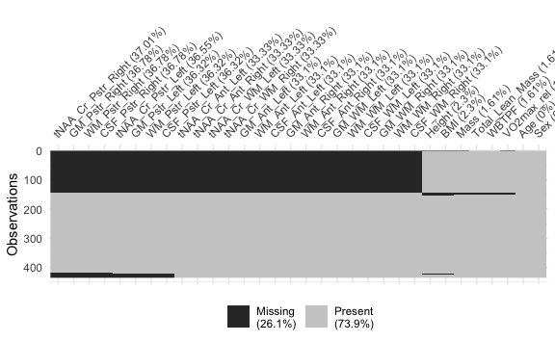

# It seems like all columns that start with tNAA or GM have the most missing data  
  
# Let's look at tNAA_Cr (NAA/Cr ratio) distribution  
par(mfrow = c(2, 3))  
hist(df$tNAA_Cr_Ant_Left)  
hist(df$tNAA_Cr_Ant_Right)  
hist(df$tNAA_Cr_Pstr_Left)  
hist(df$tNAA_Cr_Pstr_Right)  
hist(df$tNAA_Cr_WM_Left)  
hist(df$tNAA_Cr_WM_Right)

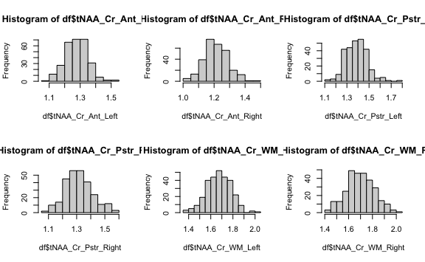

# The data seem normally distributed with low SD so I will impute using the mean  
  
df$tNAA_Cr_Ant_Left[is.na(df$tNAA_Cr_Ant_Left)] <- mean(df$tNAA_Cr_Ant_Left, na.rm = TRUE)  
df$tNAA_Cr_Ant_Right[is.na(df$tNAA_Cr_Ant_Right)] <- mean(df$tNAA_Cr_Ant_Right, na.rm = TRUE)  
df$tNAA_Cr_Pstr_Left[is.na(df$tNAA_Cr_Pstr_Left)] <- mean(df$tNAA_Cr_Pstr_Left, na.rm = TRUE)  
df$tNAA_Cr_Pstr_Right[is.na(df$tNAA_Cr_Pstr_Right)] <- mean(df$tNAA_Cr_Pstr_Right, na.rm = TRUE)  
df$tNAA_Cr_WM_Left[is.na(df$tNAA_Cr_WM_Left)] <- mean(df$tNAA_Cr_WM_Left, na.rm = TRUE)  
df$tNAA_Cr_WM_Right[is.na(df$tNAA_Cr_WM_Right)] <- mean(df$tNAA_Cr_WM_Right, na.rm = TRUE)  
  
# Let's look at GM (gray matter fraction)  
par(mfrow = c(2, 3))  
hist(df$GM_Ant_Left)  
hist(df$GM_Ant_Right)  
hist(df$GM_Pstr_Left)  
hist(df$GM_Pstr_Right)  
hist(df$GM_WM_Left)  
hist(df$GM_WM_Right)

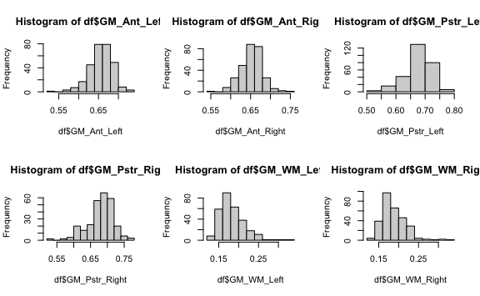

# These data seem to be more skewed, so I will impute using median  
df$GM_Ant_Left[is.na(df$GM_Ant_Left)] <- median(df$GM_Ant_Left, na.rm = TRUE)  
df$GM_Ant_Right[is.na(df$GM_Ant_Right)] <- median(df$GM_Ant_Right, na.rm = TRUE)  
df$GM_Pstr_Left[is.na(df$GM_Pstr_Left)] <- median(df$GM_Pstr_Left, na.rm = TRUE)  
df$GM_Pstr_Right[is.na(df$GM_Pstr_Right)] <- median(df$GM_Pstr_Right, na.rm = TRUE)  
df$GM_WM_Left[is.na(df$GM_WM_Left)] <- median(df$GM_WM_Left, na.rm = TRUE)  
df$GM_WM_Right[is.na(df$GM_WM_Right)] <- median(df$GM_WM_Right, na.rm = TRUE)  
  
# White matter fraction  
par(mfrow = c(2, 3))  
hist(df$WM_Ant_Left)   
hist(df$WM_Ant_Right)  
hist(df$WM_Pstr_Left)  
hist(df$WM_Pstr_Right) # the three above seem normally disributed; these three  
hist(df$WM_WM_Left) # seem right-skewed  
hist(df$WM_WM_Right)

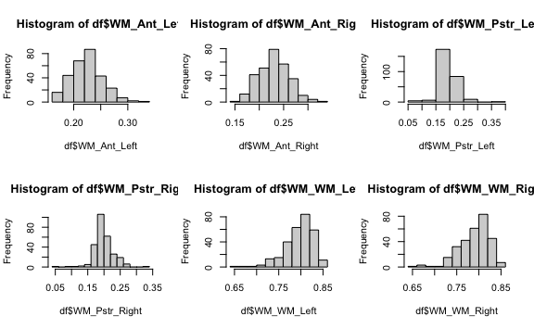

# 3 imputed using mean; 3 using median  
df$WM_Ant_Left[is.na(df$WM_Ant_Left)] <- mean(df$WM_Ant_Left, na.rm = TRUE)  
df$WM_Ant_Right[is.na(df$WM_Ant_Right)] <- mean(df$WM_Ant_Right, na.rm = TRUE)  
df$WM_Pstr_Left[is.na(df$WM_Pstr_Left)] <- mean(df$WM_Pstr_Left, na.rm = TRUE)  
df$WM_Pstr_Right[is.na(df$WM_Pstr_Right)] <- median(df$WM_Pstr_Right, na.rm = TRUE)  
df$WM_WM_Left[is.na(df$WM_WM_Left)] <- median(df$WM_WM_Left, na.rm = TRUE)  
df$WM_WM_Right[is.na(df$WM_WM_Right)] <- median(df$WM_WM_Right, na.rm = TRUE)  
  
# CSF  
par(mfrow = c(2, 3))  
hist(df$CSF_Ant_Right) # left skew  
hist(df$CSF_Ant_Left) # left skew  
hist(df$CSF_WM_Right) # left skew  
hist(df$CSF_WM_Left) # left skew  
hist(df$CSF_Pstr_Right) # left skew  
hist(df$CSF_Pstr_Left) # left skew

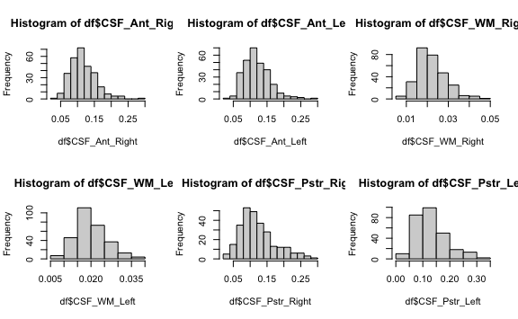

# These data are all left skewed; will impute with median  
df$CSF_Ant_Right[is.na(df$CSF_Ant_Right)] <- median(df$CSF_Ant_Right, na.rm = TRUE)  
df$CSF_Ant_Left[is.na(df$CSF_Ant_Left)] <- median(df$CSF_Ant_Left, na.rm = TRUE)  
df$CSF_WM_Right[is.na(df$CSF_WM_Right)] <- median(df$CSF_WM_Right, na.rm = TRUE)  
df$CSF_WM_Left[is.na(df$CSF_WM_Left)] <- median(df$CSF_WM_Left, na.rm = TRUE)  
df$CSF_Pstr_Right[is.na(df$CSF_Pstr_Right)] <- median(df$CSF_Pstr_Right, na.rm = TRUE)  
df$CSF_Pstr_Left[is.na(df$CSF_Pstr_Left)] <- median(df$CSF_Pstr_Left, na.rm = TRUE)  
  
# Visualize missing data again  
vis_miss(df, cluster = TRUE, sort_miss = TRUE)

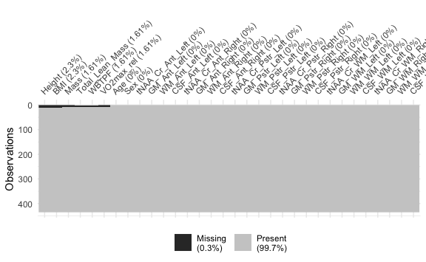

# Now it's just a few missing values in height, bmi, mass, lean mass, wbtpf,  
# and vo2max  
sapply(df, function(y) sum(length(which(is.na(y))))) # See how many NAs in each column

## Age Sex Height Mass   
## 0 0 10 7   
## Total_Lean_Mass BMI WBTPF VO2max_rel   
## 7 10 7 7   
## tNAA_Cr_Ant_Left GM_Ant_Left WM_Ant_Left CSF_Ant_Left   
## 0 0 0 0   
## tNAA_Cr_Ant_Right GM_Ant_Right WM_Ant_Right CSF_Ant_Right   
## 0 0 0 0   
## tNAA_Cr_Pstr_Left GM_Pstr_Left WM_Pstr_Left CSF_Pstr_Left   
## 0 0 0 0   
## tNAA_Cr_Pstr_Right GM_Pstr_Right WM_Pstr_Right CSF_Pstr_Right   
## 0 0 0 0   
## tNAA_Cr_WM_Left GM_WM_Left WM_WM_Left CSF_WM_Left   
## 0 0 0 0   
## tNAA_Cr_WM_Right GM_WM_Right WM_WM_Right CSF_WM_Right   
## 0 0 0 0

# Height  
hist(df$Height) # Normal

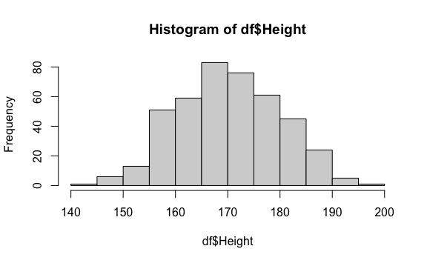

df$Height[is.na(df$Height)] <- mean(df$Height, na.rm = TRUE)  
  
# BMI  
hist(df$BMI) # Left skew

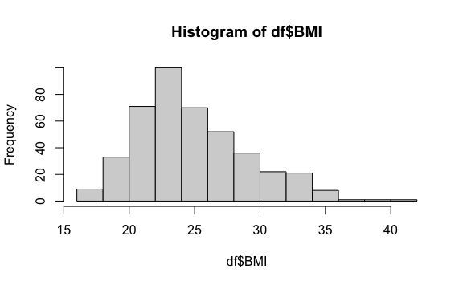

df$BMI[is.na(df$BMI)] <- mean(df$BMI, na.rm = TRUE)  
  
# Mass  
hist(df$Mass) # Left skew

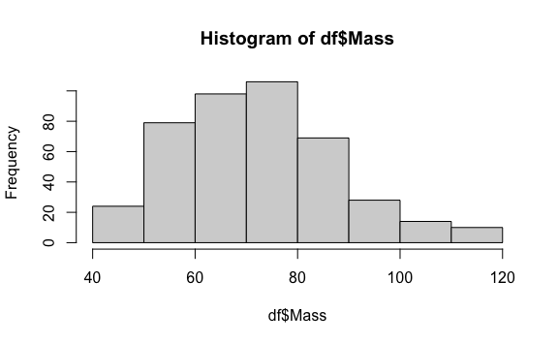

df$Mass[is.na(df$Mass)] <- median(df$Mass, na.rm = TRUE)

# Total lean mass, wbtpf, vo2max  
hist(df$Total_Lean_Mass) # Uniform

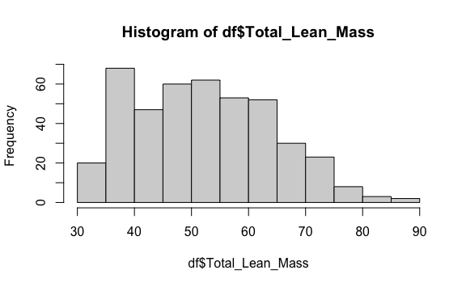

hist(df$WBTPF) # Somewhat unform

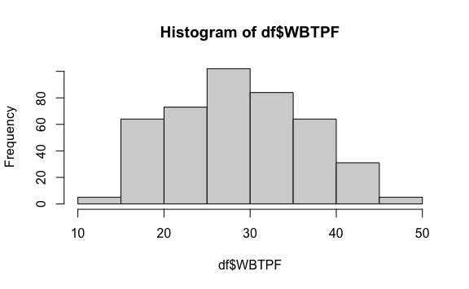

hist(df$VO2max_rel) # Normal

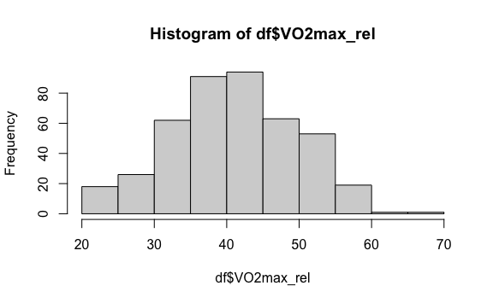

# These variables are so important to the analysis that I don't want to impute them  
# There's only 7 missing values for each of these three variables, and they're all  
# in the same row. They make up a tiny portion of the data (7/435 observations)  
# so I'm just going to drop them from the dataframe  
  
df <- df %>%   
 filter(!is.na(Total_Lean_Mass) & !is.na(WBTPF) & !is.na(VO2max_rel))  
  
# Visualize missing data again  
vis_miss(df, cluster = TRUE, sort_miss = TRUE)

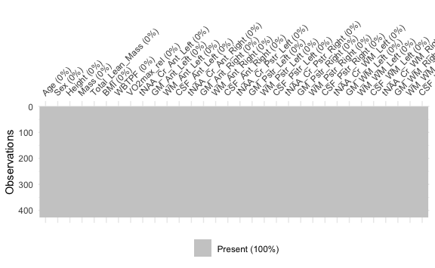

# No more missing data (yay)  
  
par(mfrow = c(1, 1)) # Fix graph display

# Hypothesizing E(y) ------------------------------------------------------  
  
# I know VO2peak is closely associated with age, so let's make that our base  
# model  
base_model <- lm(VO2max_rel ~ Age, data = df)  
summary(base_model)

##   
## Call:  
## lm(formula = VO2max_rel ~ Age, data = df)  
##   
## Residuals:  
## Min 1Q Median 3Q Max   
## -20.3205 -5.8977 0.0846 5.8622 26.3572   
##   
## Coefficients:  
## Estimate Std. Error t value Pr(>|t|)   
## (Intercept) 52.27634 1.99447 26.211 < 2e-16 ***  
## Age -0.46915 0.08155 -5.753 1.68e-08 ***  
## ---  
## Signif. codes: 0 '***' 0.001 '**' 0.01 '*' 0.05 '.' 0.1 ' ' 1  
##   
## Residual standard error: 8.399 on 425 degrees of freedom  
## Multiple R-squared: 0.07225, Adjusted R-squared: 0.07007   
## F-statistic: 33.1 on 1 and 425 DF, p-value: 1.678e-08

confint(base_model)

## 2.5 % 97.5 %  
## (Intercept) 48.3560942 56.1965888  
## Age -0.6294311 -0.3088637

plot(df$Age, df$VO2max_rel, xlab = 'Age', ylab = 'VO2peak', main = 'VO2peak vs. Age')  
abline(base_model, col = 'red')

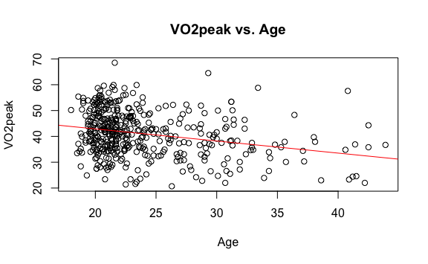

# Lets add sex  
base_model <- lm(VO2max_rel ~ Age + Sex, data = df)  
summary(base_model)

##   
## Call:  
## lm(formula = VO2max_rel ~ Age + Sex, data = df)  
##   
## Residuals:  
## Min 1Q Median 3Q Max   
## -23.8125 -4.3391 0.0242 4.9790 22.0055   
##   
## Coefficients:  
## Estimate Std. Error t value Pr(>|t|)   
## (Intercept) 46.4409 1.7288 26.864 < 2e-16 ***  
## Age -0.4217 0.0685 -6.156 1.73e-09 ***  
## SexM 9.1620 0.6830 13.414 < 2e-16 ***  
## ---  
## Signif. codes: 0 '***' 0.001 '**' 0.01 '*' 0.05 '.' 0.1 ' ' 1  
##   
## Residual standard error: 7.045 on 424 degrees of freedom  
## Multiple R-squared: 0.3487, Adjusted R-squared: 0.3456   
## F-statistic: 113.5 on 2 and 424 DF, p-value: < 2.2e-16

crPlots(base_model)

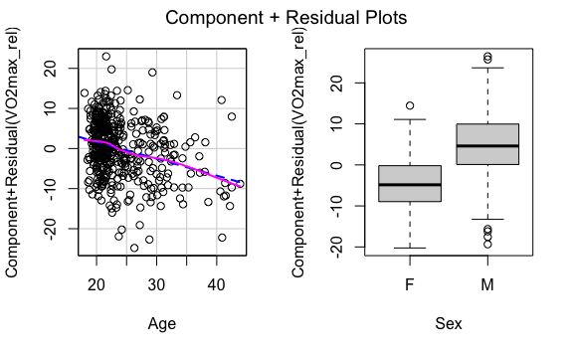

# First, I want to see the correlation between relativeVO2max and   
# all other variables  
# There's 33 variables in this dataframe, so I'll use a package, corrr, to  
# make my analysis easier  
correlation <- df %>%   
 correlate() %>%   
 focus(VO2max_rel) %>%   
 arrange(desc(VO2max_rel)) %>%   
 print(n = Inf)

## # A tibble: 30 × 2  
## term VO2max_rel  
## <chr> <dbl>  
## 1 Height 0.375   
## 2 Total_Lean_Mass 0.338   
## 3 tNAA_Cr_WM_Left 0.143   
## 4 tNAA_Cr_WM_Right 0.0989   
## 5 WM_WM_Right 0.0887   
## 6 CSF_Pstr_Left 0.0754   
## 7 WM_WM_Left 0.0747   
## 8 CSF_Pstr_Right 0.0458   
## 9 GM_Ant_Right 0.0114   
## 10 CSF_Ant_Left 0.00686  
## 11 tNAA_Cr_Ant_Left 0.00568  
## 12 WM_Ant_Left 0.00523  
## 13 CSF_Ant_Right 0.00394  
## 14 tNAA_Cr_Ant_Right -0.00406  
## 15 CSF_WM_Right -0.00879  
## 16 CSF_WM_Left -0.0108   
## 17 GM_Pstr_Right -0.0133   
## 18 GM_Ant_Left -0.0157   
## 19 WM_Ant_Right -0.0157   
## 20 tNAA_Cr_Pstr_Left -0.0266   
## 21 tNAA_Cr_Pstr_Right -0.0275   
## 22 GM_Pstr_Left -0.0438   
## 23 Mass -0.0620   
## 24 WM_Pstr_Right -0.0627   
## 25 WM_Pstr_Left -0.0750   
## 26 GM_WM_Left -0.0794   
## 27 GM_WM_Right -0.0971   
## 28 Age -0.269   
## 29 BMI -0.329   
## 30 WBTPF -0.804

# Let's visualize this using ggplot  
ggplot(correlation, aes(x = fct_reorder(term, VO2max_rel), y = VO2max_rel)) +  
 geom_col(aes(fill = VO2max_rel > 0), show.legend = FALSE) +  
 theme(axis.text.x = element_text(angle = 90, vjust = 0.5, hjust=1)) +  
 ggtitle("Correlation coefficient (r) between VO2max_rel and 33 independent variables ") +  
 xlab("Variable") +  
 ylab("Correlation coefficient with VO2max_rel")

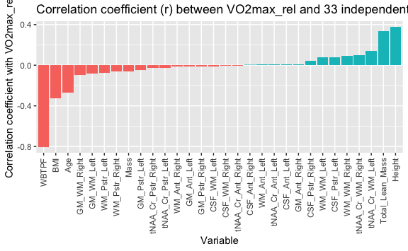

# Height, followed by lean mass, and white matter fraction, seem to have the   
# strongest positive association with VO2peak  
# Whole body total percent fat (WBTPF) seems to have a very strong negative  
# association with VO2peak  
pairs(df[, c('VO2max_rel', 'Height', 'Total_Lean_Mass',  
 'tNAA_Cr_WM_Left')], lower.panel = NULL, main = 'Scatterplots of vars with + linear association to relative VO2max')

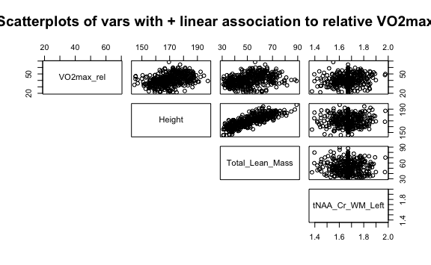

pairs(df[, c('Age', 'BMI','WBTPF')], lower.panel = NULL,  
 main = 'Scatterplots of vars with - linear association to relative VO2max')

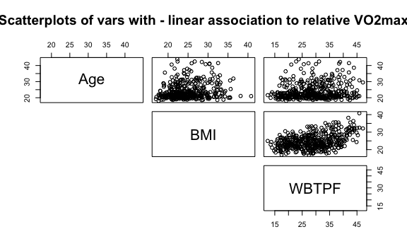

pairs(df[, c('VO2max_rel', 'Height', 'Total_Lean_Mass',  
 'tNAA_Cr_WM_Left', 'Age', 'BMI','WBTPF')], lower.panel = NULL,   
 main = 'Scatterplots of vars with linear association to relative VO2max')

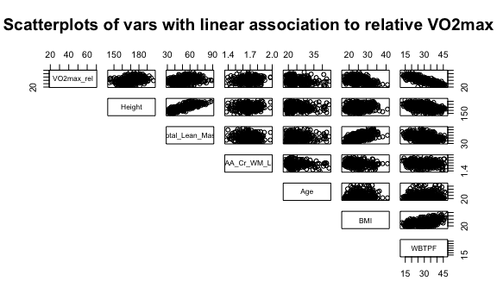

# For now, my hypothesized model will be:  
model_one <- lm(VO2max_rel ~ Height + Total_Lean_Mass + tNAA_Cr_WM_Left +  
 Age + BMI + WBTPF, data = df)  
summary(model_one)

##   
## Call:  
## lm(formula = VO2max_rel ~ Height + Total_Lean_Mass + tNAA_Cr_WM_Left +   
## Age + BMI + WBTPF, data = df)  
##   
## Residuals:  
## Min 1Q Median 3Q Max   
## -23.2050 -3.0257 0.0513 2.9886 17.6969   
##   
## Coefficients:  
## Estimate Std. Error t value Pr(>|t|)   
## (Intercept) 69.41239 12.20313 5.688 2.41e-08 ***  
## Height -0.03323 0.08206 -0.405 0.686   
## Total_Lean_Mass 0.01890 0.12789 0.148 0.883   
## tNAA_Cr_WM_Left 4.47716 2.81726 1.589 0.113   
## Age -0.27632 0.04997 -5.530 5.65e-08 ***  
## BMI 0.06963 0.26698 0.261 0.794   
## WBTPF -0.90995 0.10606 -8.579 < 2e-16 ***  
## ---  
## Signif. codes: 0 '***' 0.001 '**' 0.01 '*' 0.05 '.' 0.1 ' ' 1  
##   
## Residual standard error: 4.999 on 420 degrees of freedom  
## Multiple R-squared: 0.6752, Adjusted R-squared: 0.6706   
## F-statistic: 145.5 on 6 and 420 DF, p-value: < 2.2e-16

crPlots(model_one)

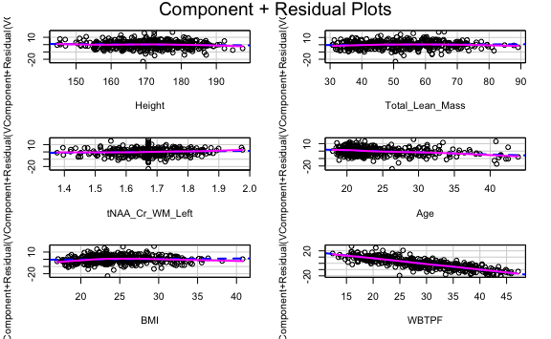

# This model seems pretty good, with an F-stat < 2.2*10^-16, and  
# an R squared of 0.6707

# Let's add sex  
model_one_sex <- lm(VO2max_rel ~ Height + Total_Lean_Mass + tNAA_Cr_WM_Left +  
 Age + BMI + WBTPF + Sex, data = df)  
summary(model_one_sex)

##   
## Call:  
## lm(formula = VO2max_rel ~ Height + Total_Lean_Mass + tNAA_Cr_WM_Left +   
## Age + BMI + WBTPF + Sex, data = df)  
##   
## Residuals:  
## Min 1Q Median 3Q Max   
## -23.5886 -3.0401 0.0628 2.9475 17.5469   
##   
## Coefficients:  
## Estimate Std. Error t value Pr(>|t|)   
## (Intercept) 70.33743 12.24238 5.745 1.77e-08 ***  
## Height -0.04339 0.08275 -0.524 0.6003   
## Total_Lean_Mass 0.00725 0.12848 0.056 0.9550   
## tNAA_Cr_WM_Left 4.74503 2.83135 1.676 0.0945 .   
## Age -0.27287 0.05010 -5.446 8.79e-08 ***  
## BMI 0.05448 0.26747 0.204 0.8387   
## WBTPF -0.88234 0.10991 -8.027 1.01e-14 ***  
## SexM 0.89372 0.93218 0.959 0.3382   
## ---  
## Signif. codes: 0 '***' 0.001 '**' 0.01 '*' 0.05 '.' 0.1 ' ' 1  
##   
## Residual standard error: 4.999 on 419 degrees of freedom  
## Multiple R-squared: 0.6759, Adjusted R-squared: 0.6705   
## F-statistic: 124.8 on 7 and 419 DF, p-value: < 2.2e-16

# Not much better

# Stepwise regression -----------------------------------------------------  
  
# Let's see if stepwise regression can identify any other relevant variables  
  
model_all <- lm(VO2max_rel ~ ., data = df)  
summary(model_all)

##   
## Call:  
## lm(formula = VO2max_rel ~ ., data = df)  
##   
## Residuals:  
## Min 1Q Median 3Q Max   
## -23.5269 -3.0750 0.3206 2.8089 17.0433   
##   
## Coefficients: (3 not defined because of singularities)  
## Estimate Std. Error t value Pr(>|t|)   
## (Intercept) -129.49437 510.02933 -0.254 0.79971   
## Age -0.27666 0.05285 -5.235 2.67e-07 ***  
## SexM 0.91437 0.95648 0.956 0.33967   
## Height 0.12353 0.10930 1.130 0.25905   
## Mass -0.53426 0.21473 -2.488 0.01325 *   
## Total_Lean_Mass 0.47187 0.23195 2.034 0.04257 *   
## BMI 0.65312 0.36564 1.786 0.07482 .   
## WBTPF -0.52611 0.18445 -2.852 0.00457 **   
## tNAA_Cr_Ant_Left -1.22857 9.57313 -0.128 0.89795   
## GM_Ant_Left -79.85174 542.50310 -0.147 0.88306   
## WM_Ant_Left -49.11803 539.14108 -0.091 0.92746   
## CSF_Ant_Left -127.31086 531.22886 -0.240 0.81072   
## tNAA_Cr_Ant_Right -5.56968 9.05352 -0.615 0.53878   
## GM_Ant_Right -78.01120 61.60892 -1.266 0.20617   
## WM_Ant_Right -94.65128 61.81495 -1.531 0.12651   
## CSF_Ant_Right NA NA NA NA   
## tNAA_Cr_Pstr_Left 8.98227 6.21606 1.445 0.14924   
## GM_Pstr_Left 287.77893 952.57855 0.302 0.76273   
## WM_Pstr_Left 252.20296 948.74622 0.266 0.79051   
## CSF_Pstr_Left 294.14239 940.30070 0.313 0.75458   
## tNAA_Cr_Pstr_Right -8.80963 5.67812 -1.552 0.12158   
## GM_Pstr_Right -181.74907 400.50190 -0.454 0.65022   
## WM_Pstr_Right -156.68162 397.12779 -0.395 0.69340   
## CSF_Pstr_Right -181.24157 388.93681 -0.466 0.64148   
## tNAA_Cr_WM_Left 10.77339 5.72086 1.883 0.06041 .   
## GM_WM_Left 49.27870 163.19569 0.302 0.76284   
## WM_WM_Left 50.61236 161.79653 0.313 0.75459   
## CSF_WM_Left NA NA NA NA   
## tNAA_Cr_WM_Right -4.59074 5.90676 -0.777 0.43750   
## GM_WM_Right 159.63978 132.55023 1.204 0.22916   
## WM_WM_Right 168.04618 128.86239 1.304 0.19296   
## CSF_WM_Right NA NA NA NA   
## ---  
## Signif. codes: 0 '***' 0.001 '**' 0.01 '*' 0.05 '.' 0.1 ' ' 1  
##   
## Residual standard error: 4.988 on 398 degrees of freedom  
## Multiple R-squared: 0.6935, Adjusted R-squared: 0.6719   
## F-statistic: 32.16 on 28 and 398 DF, p-value: < 2.2e-16

# R^2=0.6729

# We'll do forward selection first   
ols_step_forward_p(model_all, penter = 0.05)

##   
## Selection Summary   
## --------------------------------------------------------------------------  
## Variable Adj.   
## Step Entered R-Square R-Square C(p) AIC RMSE   
## --------------------------------------------------------------------------  
## 1 WBTPF 0.6471 0.6462 35.3172 2620.4509 5.1801   
## 2 Age 0.6720 0.6705 4.9061 2591.1336 4.9995   
## --------------------------------------------------------------------------

# The only variables entered were WBTPF and Age  
model_forward <- lm(VO2max_rel ~ WBTPF + Age, data = df)  
summary(model_forward)

##   
## Call:  
## lm(formula = VO2max_rel ~ WBTPF + Age, data = df)  
##   
## Residuals:  
## Min 1Q Median 3Q Max   
## -23.2057 -3.2876 0.1243 3.0059 18.3147   
##   
## Coefficients:  
## Estimate Std. Error t value Pr(>|t|)   
## (Intercept) 73.45994 1.41009 52.10 < 2e-16 ***  
## WBTPF -0.89142 0.03201 -27.84 < 2e-16 ***  
## Age -0.27847 0.04902 -5.68 2.5e-08 ***  
## ---  
## Signif. codes: 0 '***' 0.001 '**' 0.01 '*' 0.05 '.' 0.1 ' ' 1  
##   
## Residual standard error: 4.999 on 424 degrees of freedom  
## Multiple R-squared: 0.672, Adjusted R-squared: 0.6705   
## F-statistic: 434.4 on 2 and 424 DF, p-value: < 2.2e-16

# R^2=0.6705

# Backward selection----  
ols_step_backward_p(model_all, prem = 0.05)

##   
##   
## Elimination Summary   
## ------------------------------------------------------------------------------------  
## Variable Adj.   
## Step Removed R-Square R-Square C(p) AIC RMSE   
## ------------------------------------------------------------------------------------  
## 1 tNAA_Cr_Ant_Left 0.6935 0.6728 27.0165 2618.2148 4.9821   
## 2 WM_Pstr_Left 0.6934 0.6735 25.0837 2616.2870 4.9763   
## 3 WM_Pstr_Right 0.6934 0.6743 23.1837 2614.3942 4.9707   
## 4 tNAA_Cr_Ant_Right 0.6927 0.6743 22.0600 2613.3329 4.9700   
## 5 tNAA_Cr_WM_Right 0.6921 0.6746 20.7942 2612.1177 4.9684   
## 6 CSF_Pstr_Right 0.6914 0.6746 19.7643 2611.1526 4.9683   
## 7 tNAA_Cr_Pstr_Left 0.6908 0.6748 18.5103 2609.9468 4.9667   
## 8 GM_Pstr_Right 0.6903 0.6751 17.1087 2608.5826 4.9643   
## 9 Sex 0.6895 0.675 16.2675 2607.8114 4.9654   
## 10 Height 0.6883 0.6746 15.7008 2607.3264 4.9681   
## 11 tNAA_Cr_Pstr_Right 0.687 0.674 15.3932 2607.1083 4.9724   
## 12 tNAA_Cr_WM_Left 0.6857 0.6735 15.0823 2606.8793 4.9766   
## 13 BMI 0.6843 0.6728 14.9041 2606.7813 4.9816   
## 14 GM_Pstr_Left 0.6829 0.6722 14.7426 2606.6923 4.9867   
## 15 CSF_Pstr_Left 0.6814 0.6714 14.6910 2606.7081 4.9924   
## ------------------------------------------------------------------------------------

# Age, mass, lean mass, wbtpf, gm_ant_right, wm, csf, were kept  
model_backward <- lm(VO2max_rel ~ Age + Mass + Total_Lean_Mass +  
 WBTPF + GM_Ant_Left + WM_Ant_Left +  
 CSF_Ant_Left + GM_Ant_Right + WM_Ant_Right +  
 CSF_Ant_Right + GM_WM_Left + WM_WM_Left +  
 CSF_WM_Left + GM_WM_Right + WM_WM_Right +  
 CSF_WM_Right, data = df)  
summary(model_backward)

##   
## Call:  
## lm(formula = VO2max_rel ~ Age + Mass + Total_Lean_Mass + WBTPF +   
## GM_Ant_Left + WM_Ant_Left + CSF_Ant_Left + GM_Ant_Right +   
## WM_Ant_Right + CSF_Ant_Right + GM_WM_Left + WM_WM_Left +   
## CSF_WM_Left + GM_WM_Right + WM_WM_Right + CSF_WM_Right, data = df)  
##   
## Residuals:  
## Min 1Q Median 3Q Max   
## -23.0792 -2.9775 0.2452 2.8483 17.5881   
##   
## Coefficients: (3 not defined because of singularities)  
## Estimate Std. Error t value Pr(>|t|)   
## (Intercept) 99.24224 187.25980 0.530 0.5964   
## Age -0.28432 0.05148 -5.523 5.91e-08 ***  
## Mass -0.31898 0.15781 -2.021 0.0439 *   
## Total_Lean_Mass 0.46857 0.22470 2.085 0.0377 *   
## WBTPF -0.53781 0.17532 -3.068 0.0023 **   
## GM_Ant_Left -135.12238 182.27983 -0.741 0.4589   
## WM_Ant_Left -120.76312 180.95386 -0.667 0.5049   
## CSF_Ant_Left -193.63296 168.17280 -1.151 0.2502   
## GM_Ant_Right -83.02012 59.46468 -1.396 0.1634   
## WM_Ant_Right -100.24632 58.98009 -1.700 0.0899 .   
## CSF_Ant_Right NA NA NA NA   
## GM_WM_Left 60.92778 151.54992 0.402 0.6879   
## WM_WM_Left 67.73545 149.58251 0.453 0.6509   
## CSF_WM_Left NA NA NA NA   
## GM_WM_Right 114.93072 124.05404 0.926 0.3547   
## WM_WM_Right 116.54302 119.46202 0.976 0.3299   
## CSF_WM_Right NA NA NA NA   
## ---  
## Signif. codes: 0 '***' 0.001 '**' 0.01 '*' 0.05 '.' 0.1 ' ' 1  
##   
## Residual standard error: 4.992 on 413 degrees of freedom  
## Multiple R-squared: 0.6814, Adjusted R-squared: 0.6714   
## F-statistic: 67.95 on 13 and 413 DF, p-value: < 2.2e-16

# R^2=0.6714

# Stepwise selection  
ols_step_both_p(model_all, penter=0.05, prem=0.1)

##   
## Stepwise Selection Summary   
## ------------------------------------------------------------------------------------------  
## Added/ Adj.   
## Step Variable Removed R-Square R-Square C(p) AIC RMSE   
## ------------------------------------------------------------------------------------------  
## 1 WBTPF addition 0.647 0.646 35.3170 2620.4509 5.1801   
## 2 Age addition 0.672 0.670 4.9060 2591.1336 4.9995   
## 3 CSF_WM_Right addition 0.674 0.672 4.1300 2590.3412 4.9890   
## 4 WM_Pstr_Left addition 0.677 0.674 2.2270 2588.3840 4.9719   
## ------------------------------------------------------------------------------------------

# Variables kept: WBTPF, age, csf_whitematter_right, and wm_pstr_left  
model_stepwise <- lm(VO2max_rel ~ WBTPF + Age + CSF_WM_Right + WM_Pstr_Left, data = df)  
summary(model_stepwise)

##   
## Call:  
## lm(formula = VO2max_rel ~ WBTPF + Age + CSF_WM_Right + WM_Pstr_Left,   
## data = df)  
##   
## Residuals:  
## Min 1Q Median 3Q Max   
## -23.3008 -2.9998 0.1775 2.9288 18.1028   
##   
## Coefficients:  
## Estimate Std. Error t value Pr(>|t|)   
## (Intercept) 79.50440 2.81769 28.216 < 2e-16 ***  
## WBTPF -0.89357 0.03190 -28.014 < 2e-16 ***  
## Age -0.27031 0.04885 -5.533 5.53e-08 ***  
## CSF_WM_Right -98.89377 45.08441 -2.194 0.0288 *   
## WM_Pstr_Left -20.75242 10.46954 -1.982 0.0481 *   
## ---  
## Signif. codes: 0 '***' 0.001 '**' 0.01 '*' 0.05 '.' 0.1 ' ' 1  
##   
## Residual standard error: 4.972 on 422 degrees of freedom  
## Multiple R-squared: 0.6772, Adjusted R-squared: 0.6741   
## F-statistic: 221.3 on 4 and 422 DF, p-value: < 2.2e-16

# R^2=0.6741

# Interestingly, all three stepwise approahces yielded different results  
# I'm curious about sex—let me see how VO2peak varies across sex  
vo2_sex <- data.frame('male' = mean(df$VO2max_rel[df$Sex == 'M'], na.rm = TRUE),   
 'female' = mean(df$VO2max_rel[df$Sex == 'F'], na.rm = TRUE)  
 )  
# Is this a significant difference?  
t.test(df$VO2max_rel[df$Sex == 'M'], df$VO2max_rel[df$Sex == 'F'])

##   
## Welch Two Sample t-test  
##   
## data: df$VO2max_rel[df$Sex == "M"] and df$VO2max_rel[df$Sex == "F"]  
## t = 13.257, df = 416.07, p-value < 2.2e-16  
## alternative hypothesis: true difference in means is not equal to 0  
## 95 percent confidence interval:  
## 7.988459 10.769949  
## sample estimates:  
## mean of x mean of y   
## 45.61142 36.23221

# Yes, with p < 10^-16  
# So I'll include sex in the analysis

model_two <- lm(VO2max_rel ~ WBTPF + Age + CSF_WM_Right + WM_Pstr_Left,  
 data = df)  
summary(model_two)  
# R^2=0.6781  
  
# What if you add sex  
model_three <- lm(VO2max_rel ~ Height + Total_Lean_Mass + tNAA_Cr_WM_Left +  
 Age + BMI + WBTPF + Sex, data = df)  
summary(model_three)  
# R^2=0.6781  
# A significant model, but R squared isn't improved

# Let's include this in the model and test for multicollinearity   
# by calculating variance inflation factor (VIF)  
vif(model_two)

## WBTPF Age CSF_WM_Right WM_Pstr_Left   
## 1.023762 1.024152 1.105998 1.104093

# Seems like there's no multicollinearity  
pred_one <- model_two

# Improving prediction model ----------------------------------------------  
  
# Let's try to improve our prediction model with residual analysis  
plot(fitted(pred_one), pred_one$residuals, main = "First-order model")

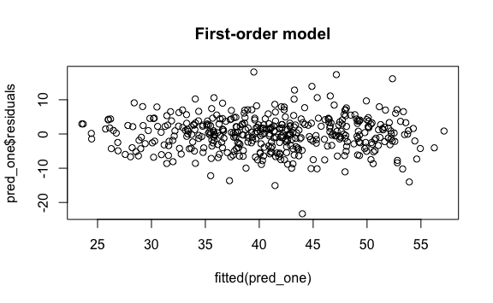

# The errors seem pretty normally distributed;   
# perhaps greater at higher values

# Perhaps we can try a poisson transformation  
df$poisson <- sqrt(df$VO2max_rel)  
pred_poisson <- lm(poisson ~ WBTPF + Age + CSF_WM_Right + WM_Pstr_Left + Sex,  
 data = df)  
summary(pred_poisson)

##   
## Call:  
## lm(formula = poisson ~ WBTPF + Age + CSF_WM_Right + WM_Pstr_Left +   
## Sex, data = df)  
##   
## Residuals:  
## Min 1Q Median 3Q Max   
## -2.06200 -0.23902 0.02223 0.23896 1.35441   
##   
## Coefficients:  
## Estimate Std. Error t value Pr(>|t|)   
## (Intercept) 9.380603 0.238569 39.320 < 2e-16 ***  
## WBTPF -0.068899 0.003331 -20.686 < 2e-16 ***  
## Age -0.022871 0.003886 -5.886 8.08e-09 ***  
## CSF_WM_Right -7.752217 3.591063 -2.159 0.0314 *   
## WM_Pstr_Left -1.675737 0.831975 -2.014 0.0446 *   
## SexM 0.039341 0.050634 0.777 0.4376   
## ---  
## Signif. codes: 0 '***' 0.001 '**' 0.01 '*' 0.05 '.' 0.1 ' ' 1  
##   
## Residual standard error: 0.3949 on 421 degrees of freedom  
## Multiple R-squared: 0.6772, Adjusted R-squared: 0.6734   
## F-statistic: 176.6 on 5 and 421 DF, p-value: < 2.2e-16

plot(fitted(pred_poisson), pred_poisson$residuals, main = "Poisson Transformation")

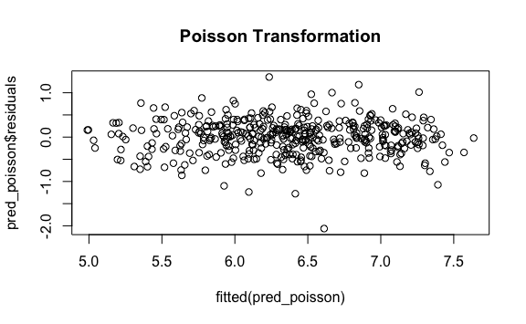

# This transformation doesn't improve R^2 (0.67 in both cases), nor does it  
# affect p-value of F-test

# How about multiplicative transformation?   
df$multiplicative <- log(df$VO2max_rel)  
pred_multiplicative <- lm(multiplicative ~ WBTPF + Age + CSF_WM_Right + WM_Pstr_Left + Sex, data = df)  
summary(pred_multiplicative)

##   
## Call:  
## lm(formula = multiplicative ~ WBTPF + Age + CSF_WM_Right + WM_Pstr_Left +   
## Sex, data = df)  
##   
## Residuals:  
## Min 1Q Median 3Q Max   
## -0.73495 -0.06889 0.01230 0.07889 0.41522   
##   
## Coefficients:  
## Estimate Std. Error t value Pr(>|t|)   
## (Intercept) 4.674623 0.078062 59.883 < 2e-16 ***  
## WBTPF -0.022243 0.001090 -20.410 < 2e-16 ***  
## Age -0.007741 0.001271 -6.089 2.56e-09 ***  
## CSF_WM_Right -2.349912 1.175031 -2.000 0.0462 *   
## WM_Pstr_Left -0.557276 0.272231 -2.047 0.0413 *   
## SexM 0.006419 0.016568 0.387 0.6986   
## ---  
## Signif. codes: 0 '***' 0.001 '**' 0.01 '*' 0.05 '.' 0.1 ' ' 1  
##   
## Residual standard error: 0.1292 on 421 degrees of freedom  
## Multiple R-squared: 0.668, Adjusted R-squared: 0.664   
## F-statistic: 169.4 on 5 and 421 DF, p-value: < 2.2e-16

plot(fitted(pred_multiplicative), pred_multiplicative$residuals, main = "Multiplicative Transformation")

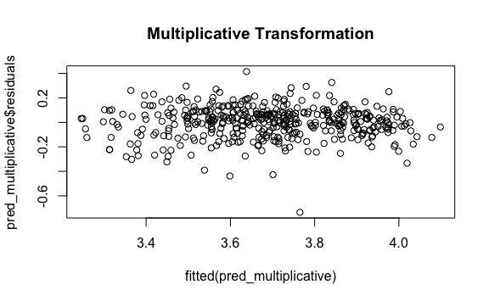

# This transformation doesn't improve R^2 (0.68 in both cases), nor does it  
# affect p-value of F-test

# How about partial residual plots?  
crPlots(pred_one)

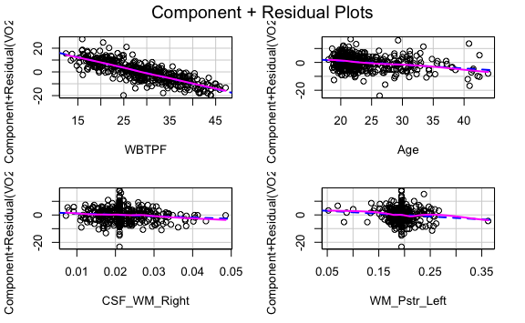

# The variables seem to have linear relationships

# I wonder if there is interaction between age and sex  
pred_two <- lm(VO2max_rel ~ WBTPF + Age + CSF_WM_Right + WM_Pstr_Left + Sex +  
 Age*Sex, data = df)  
summary(pred_two)  
anova(pred_one, pred_two, test = 'F') # nested F test says this doesn't help  
  
  
# WBTPF and age?  
pred_three <- lm(VO2max_rel ~ WBTPF + Age + CSF_WM_Right + WM_Pstr_Left +  
 Age*WBTPF, data = df)  
summary(pred_three)  
anova(pred_one, pred_three, test = 'F') # nested F test  
# Also no  
  
# Sex and WBTPF?  
pred_four <- lm(VO2max_rel ~ WBTPF + Age + CSF_WM_Right + WM_Pstr_Left + Sex +  
 Sex*WBTPF, data = df)  
summary(pred_four)  
anova(pred_one, pred_four, test = 'F') # nested F test  
  
# Age, sex, bmi?  
pred_five <- lm(VO2max_rel ~ WBTPF + Age + CSF_WM_Right + WM_Pstr_Left + Sex +  
 Age*WBTPF + Sex*WBTPF + Age*Sex+WBTPF, data = df)  
summary(pred_five)  
anova(pred_one, pred_five, test = 'F') # nested F test  
# Also no, but we're closer—p = 0.068  
  
# WBTPF^2?  
pred_six <- lm(VO2max_rel ~ WBTPF + Age + CSF_WM_Right + WM_Pstr_Left + Sex +  
 Age*WBTPF + Sex*WBTPF + Age*Sex+WBTPF + I(WBTPF^2), data = df)  
summary(pred_six)  
anova(pred_one, pred_six, test = 'F') # nested F test  
# Close; p = 0.0502

# WBTPF^2?  
pred_seven <- lm(VO2max_rel ~ WBTPF + Age + CSF_WM_Right + WM_Pstr_Left + Sex +  
 Age*WBTPF + Sex*WBTPF + Age*Sex+WBTPF + I(WBTPF^2) +  
 CSF_WM_Right*WBTPF + WM_Pstr_Left*WBTPF +  
 CSF_WM_Right* WM_Pstr_Left, data = df)  
summary(pred_seven)  
anova(pred_one, pred_seven, test = 'F') # nested F test  
# Not better, p=0.14

# How are residuals on pred_six  
plot(pred_six$res)

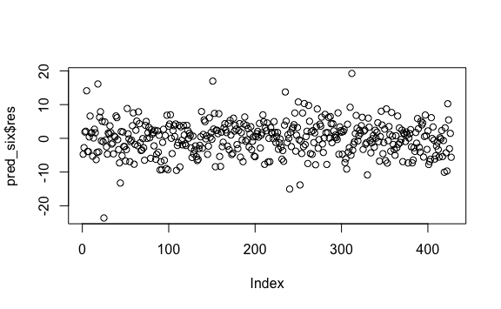

# Seem prety good

# Interpretation model ----------------------------------------------------  
interpret_one <- model_forward  
# This forward model was very simple  
  
# Let's look at its residuals  
plot(interpret_one$residuals)

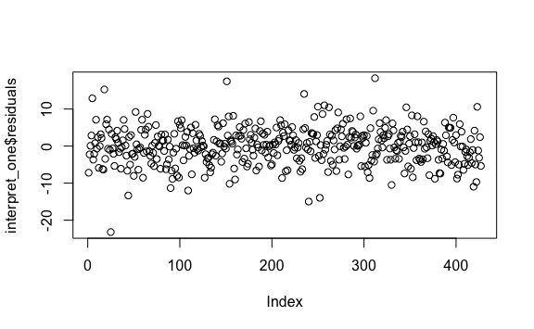

crPlots(interpret_one)

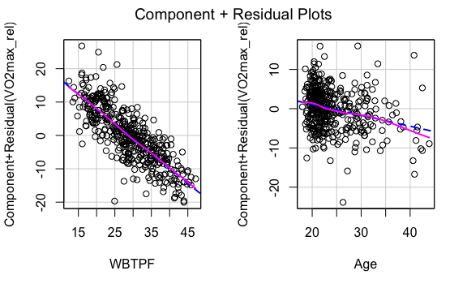

# These also seem uniformly distributed

summary(interpret_one)

##   
## Call:  
## lm(formula = VO2max_rel ~ WBTPF + Age, data = df)  
##   
## Residuals:  
## Min 1Q Median 3Q Max   
## -23.2057 -3.2876 0.1243 3.0059 18.3147   
##   
## Coefficients:  
## Estimate Std. Error t value Pr(>|t|)   
## (Intercept) 73.45994 1.41009 52.10 < 2e-16 ***  
## WBTPF -0.89142 0.03201 -27.84 < 2e-16 ***  
## Age -0.27847 0.04902 -5.68 2.5e-08 ***  
## ---  
## Signif. codes: 0 '***' 0.001 '**' 0.01 '*' 0.05 '.' 0.1 ' ' 1  
##   
## Residual standard error: 4.999 on 424 degrees of freedom  
## Multiple R-squared: 0.672, Adjusted R-squared: 0.6705   
## F-statistic: 434.4 on 2 and 424 DF, p-value: < 2.2e-16

# This model is simple with a high R^2. I'll see if adding any interaction/  
# quadratic terms improves it but it is good as is

interpret_two <- lm(VO2max_rel ~ WBTPF + Age + Sex, data = df)  
summary(interpret_two)

##   
## Call:  
## lm(formula = VO2max_rel ~ WBTPF + Age + Sex, data = df)  
##   
## Residuals:  
## Min 1Q Median 3Q Max   
## -23.4086 -3.1835 0.1202 2.9459 18.1316   
##   
## Coefficients:  
## Estimate Std. Error t value Pr(>|t|)   
## (Intercept) 72.36730 1.76303 41.047 < 2e-16 ***  
## WBTPF -0.86310 0.04216 -20.474 < 2e-16 ***  
## Age -0.28111 0.04909 -5.727 1.94e-08 ***  
## SexM 0.65890 0.63826 1.032 0.303   
## ---  
## Signif. codes: 0 '***' 0.001 '**' 0.01 '*' 0.05 '.' 0.1 ' ' 1  
##   
## Residual standard error: 4.999 on 423 degrees of freedom  
## Multiple R-squared: 0.6728, Adjusted R-squared: 0.6705   
## F-statistic: 290 on 3 and 423 DF, p-value: < 2.2e-16

anova(interpret_one, interpret_two, test = 'F')

## Analysis of Variance Table  
##   
## Model 1: VO2max_rel ~ WBTPF + Age  
## Model 2: VO2max_rel ~ WBTPF + Age + Sex  
## Res.Df RSS Df Sum of Sq F Pr(>F)  
## 1 424 10598   
## 2 423 10571 1 26.633 1.0657 0.3025

# Sex isn't worth the addition

# Body fat and age interaction  
interpret_three <- lm(VO2max_rel ~ WBTPF + Age + WBTPF*Age, data = df)  
summary(interpret_three)  
anova(interpret_one, interpret_three, test = 'F')  
  
# Body fat^2  
interpret_four <- lm(VO2max_rel ~ WBTPF + Age + I(WBTPF^2), data = df)  
summary(interpret_four)  
anova(interpret_one, interpret_four, test = 'F')  
  
# Body fat^2  
interpret_five <- lm(VO2max_rel ~ WBTPF + Age + I(Age^2), data = df)  
summary(interpret_five)  
anova(interpret_one, interpret_five, test = 'F')  
  
# None of these transformations were worth it. VO2 ~ WBTPF + Age is the best model

confint(interpret_one)

## 2.5 % 97.5 %  
## (Intercept) 70.688292 76.2315798  
## WBTPF -0.954349 -0.8284986  
## Age -0.374827 -0.1821090

1. Kokkinos P, Faselis C, Samuel IBH, et al: Cardiorespiratory Fitness and Mortality Risk Across the Spectra of Age, Race, and Sex. J Am Coll Cardiol 80:598-609, 2022
2. A summary of all models built is found in Table 1.
3. p=0.0502 from nested F-test.